The tutorial for installing Arduino IDE on Windows.

Ⅰ.Arduino IDE
As an open source software, Arduino IDE is developed based on Processing IDE, which is the integrated development environment officially launched by Arduino.

With Arduino IDE, you just write the program code in the IDE and then upload it to the Arduino board and the program will tell the Arduino board what it needs to do.

Ⅱ.Download the Arduino IDE for Windows

1.Download Arduino IDE
①Download the Arduino IDE's website address: https://www.arduino.cc/en/Main/Software, open the url according to the following chart to select the corresponding version in the future.
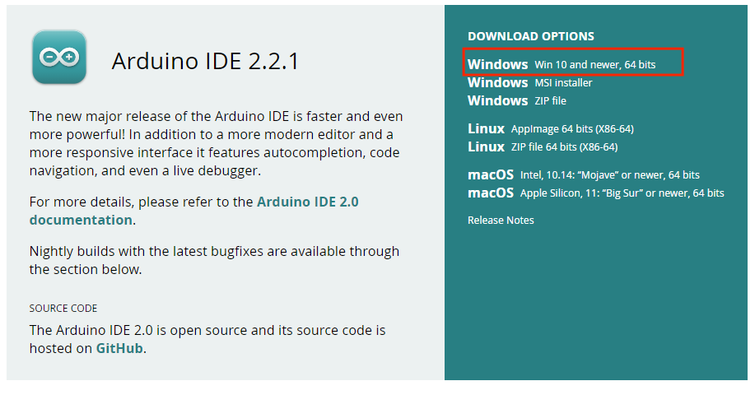
②Select JUST DOWNLOAD.

③When the following screen appears, the Arduino IDE is downloading.
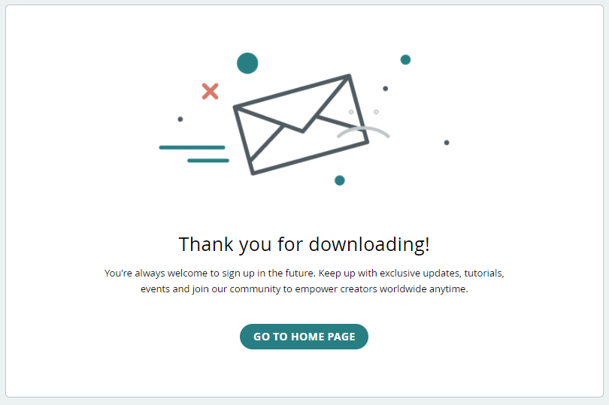

2.Install the Arduino IDE
①When the download is complete, the icon file will appear. Click Install software.
②After installation, the following screen appears and select "I Agree".
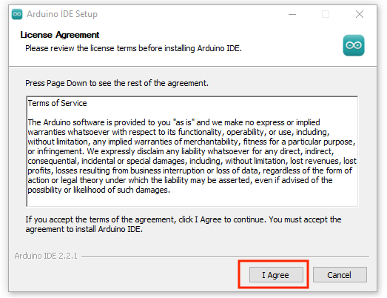
③After selecting "I Agree", the following screen will appear and select "Next".
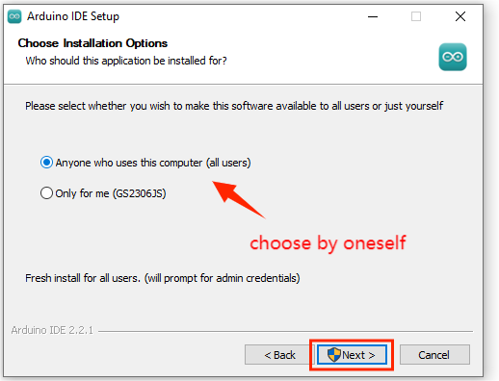
④Select "Next" and the following screen will appear. Select "Install".
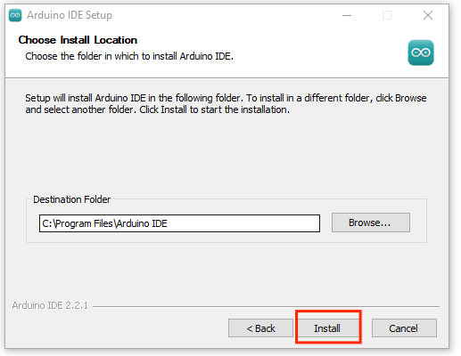
⑤Arduino IDE software installed.
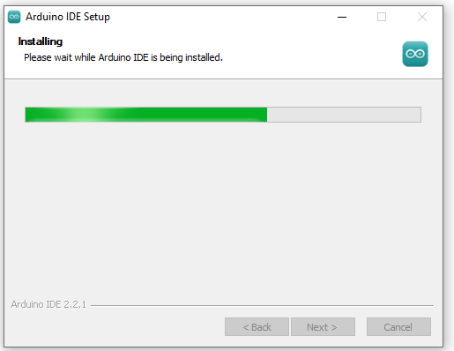
⑥Installation is complete.
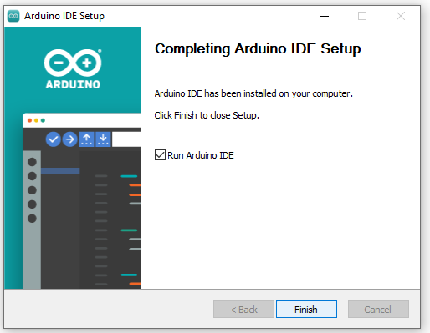

3.The Arduino IDE installation is complete

①After installation, a shortcut icon of Arduino IDE will appear on your desktop.
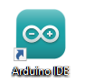
②When opened, the following screen will appear.
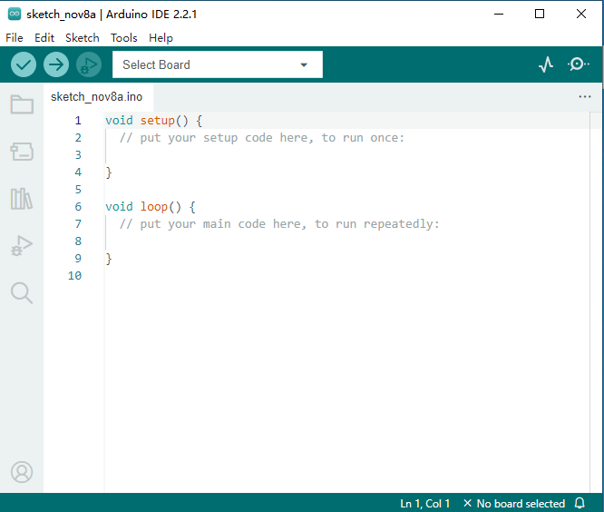

Ⅲ.How to install CH340 serial port driver
Connect the main control board to your computer with a USB cable, and the driver will be installed automatically on MacOS and Windows systems. If the driver installation fails, you need to install the driver manually.

The USB to serial port chip of ESP32 control board is CH340C. Therefore, you need to install the driver for the chip.

The driver installation process is much the same on different systems. Here, we demonstrate the driver installation on a Win10 system. You can find the "USB_Drive_CH341_3_1" folder in the resources package we provided. This is the driver file we want to install.
1.Check whether CH340 serial port driver is installed (if it is installed, skip it)
①Plug one end of the USB cable into the ESP32 control board and the other end into the USB port on the computer.
②The first time you connect the ESP32 console to your computer, right-click "My Computer" -> "Attribute" -> Click Device Manager, and under Other Devices, you will see either USB-Serial or Unknown Device.

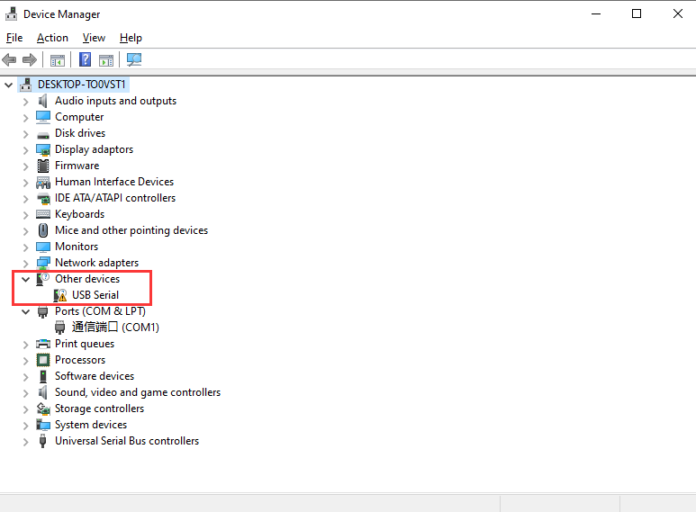

2.Install CH340 serial port driver
①First right click on the device and select the top menu option (Update Driver Software) as shown below.
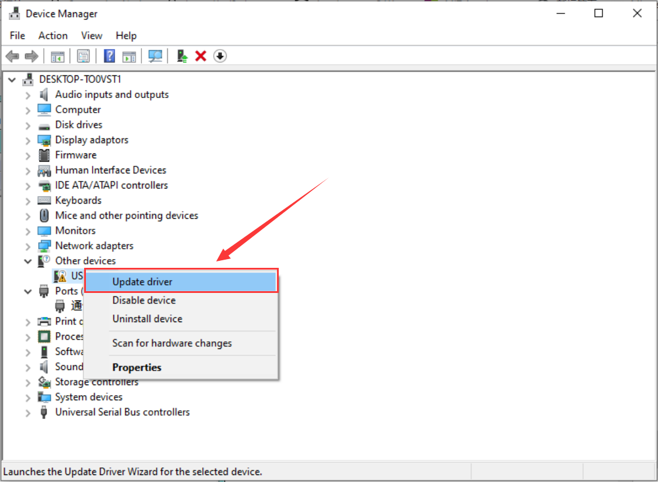
②Then you will be prompted to "Automatically search for updated driver software" or "Browse my computer to find driver software" as shown below. On this page, select "Browse My Computer to find driver software".
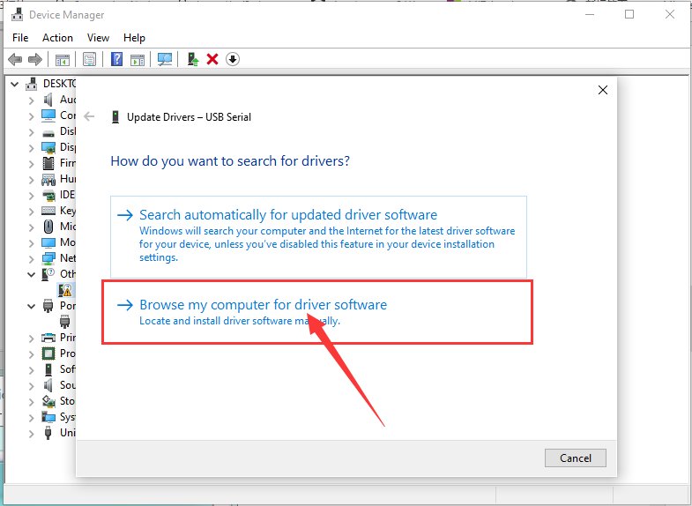
③Then, add the path to the driver file.
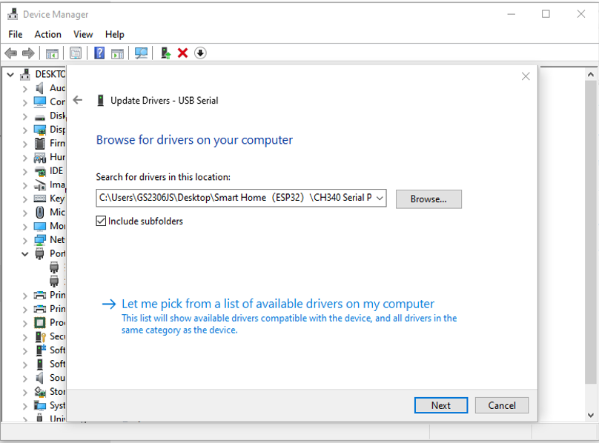
④You will receive a confirmation message after the software installation is complete. Once the installation is complete, click "Close".
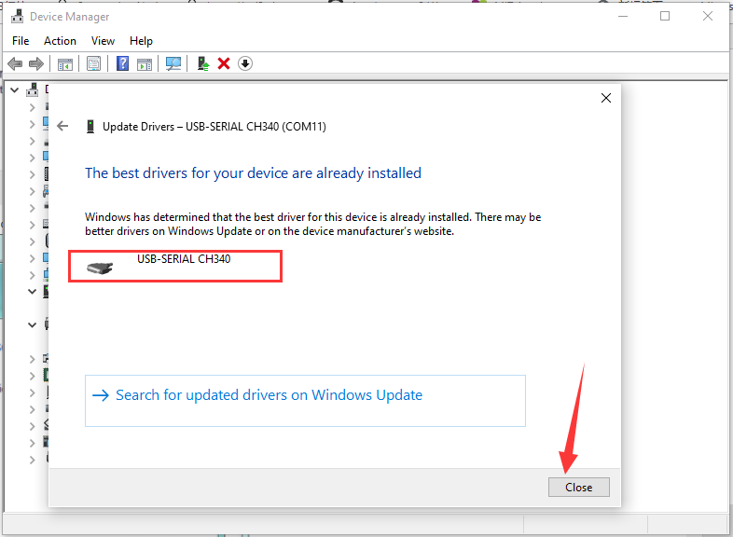

3.Confirm that the CH340 serial port driver has been installed successfully
Plug one end of the USB cable into the ESP32 control board and the other end into the USB port on the computer. Right click "My Computer " -> " Attribute " -> Click "Device Manager" and connect to the control panel. The following picture shows that the installation is successful.
